VOLVO
S90\2017-\Smart key
XC40\2020-\Smart key
XC60\2018-\Smart key
XC90\2015-\Smart key
S60\2020-\Smart key
V60\2018-\Smart key
V90\2016-\Smart key
Function
Read CEM data: read car CEM to back up security data(must dismantle CEM to read the data before programming).
Add smart key: add and program smart key.
All smart key lost: re-program keys when all registered keys are lost.
Read smart key count: read count of the programmed smart keys.

Operation
Program process:
- Use KPROG adaptor to dismantle and read the security data of car CEM module, the data will be saved in [customfile] folder in K518 memory automatically. CEM data can be used directly, no need to convert it online.
- Execute [Add smart key/all smart key lost] function, select adptor to read CEM security data and enter key programming procedure.
Read CEM data
Select chip type: (1) MPC5748G (2)MPC5646C

Please input filename to save the data;
Initialize the target chip;
Reading data...
Checking...
Reading is complete

Add smart key
This function needs to dismantle CEM, and use KPROG adaptor to read the data, two types of CEM supported:
Type 1: two CPUs(model: MPC5646C) on the mainboard_need to read 64K DFLASH data of the CPU in the middle of the mainboard;
Type 2: one CPU(model: MPC5748G) on the mainboard_need to read 6M PFLASH data of the CPU.
Then load the read data to execute Program Key function. If the data has been read already, please proceed the procedure.
Please select PFLASH or DFLASH data of CEM module;

Reading data...

Turn ignition ON;

Communicating...

Current key count: 2;

Please put the key(to be programmed) in the induction area(cup holder or armrest box), click OK start to program key;

Programming...

Current key count: 3;

Program completed.

All smart key lost

This function needs to dismantle CEM, and use KPROG adaptor to read the data, two types of CEM supported:
Type 1: two CPUs(model: MPC5646C) on the mainboard_need to read 64K DFLASH data of the CPU in the middle of the mainboard;
Type 2: one CPU(model: MPC5748G) on the mainboard_need to read 6M PFLASH data of the CPU.
Then load the read data to execute Program Key function. If the data has been read already, please proceed the procedure.
Please select PFLASH or DFLASH data of CEM module;

Reading data...

This function will delete all registered keys, please prepare keys to be programmed;

Communicating...

Current key count: 4;

Deleting keys...

All keys are deleted, next, will execute Key Add/Program operations.

Communicating...

Current key count: 0;

Please put the key(to be programmed) in the induction area(cup holder or armrest box), click OK start to program key;

Programming...

Current key count: 1;

Program completed.

Read smart key count
Turn ignition ON;

Communicating...

Current key count: 4

When using KPROG adaptor to read data, please look to the sticker orientation and pin order:
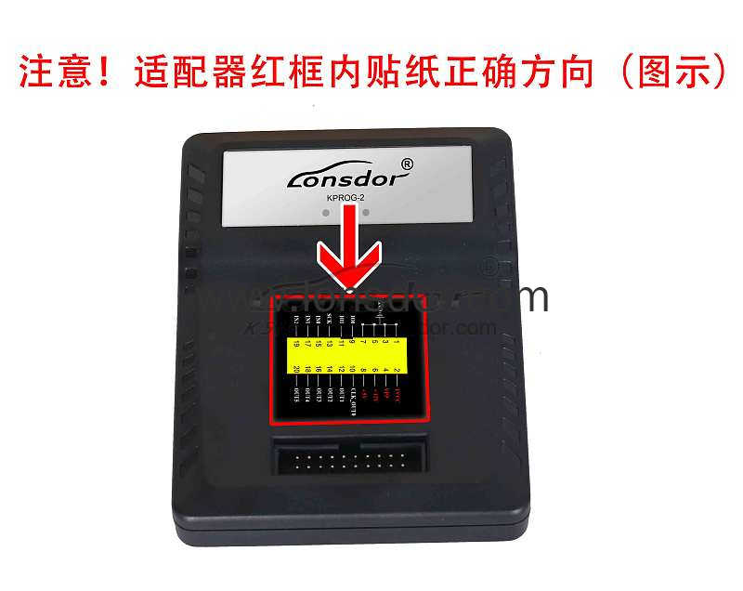

CEM location: in the bottom left under steering wheel
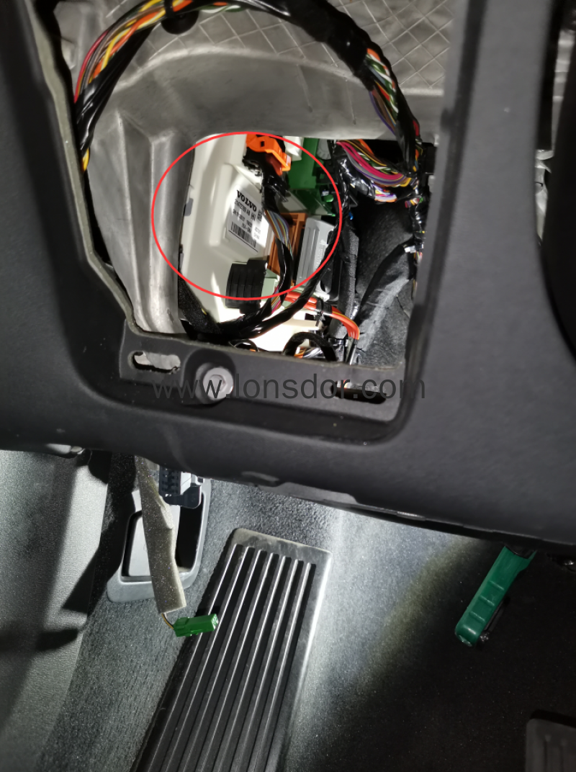
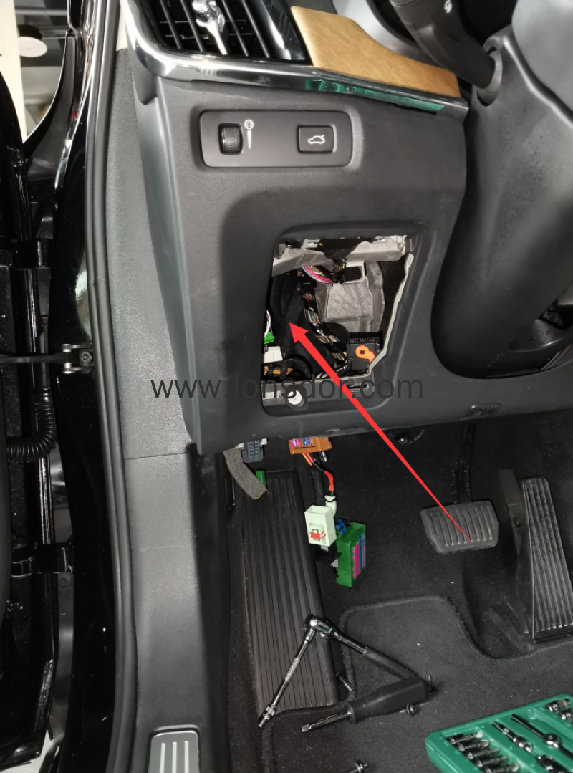

CEM appperance：
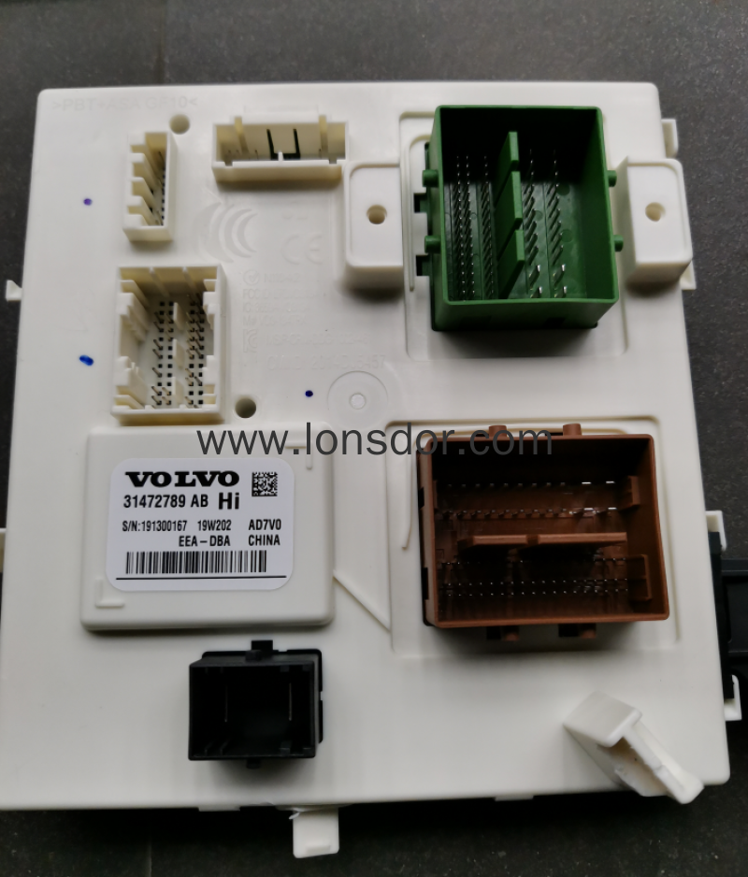

Dismantle CEM module, you will find 2 types of PCB for new car models:

(1) Type 1: two CPU with chip no.MPC5646C on PCB
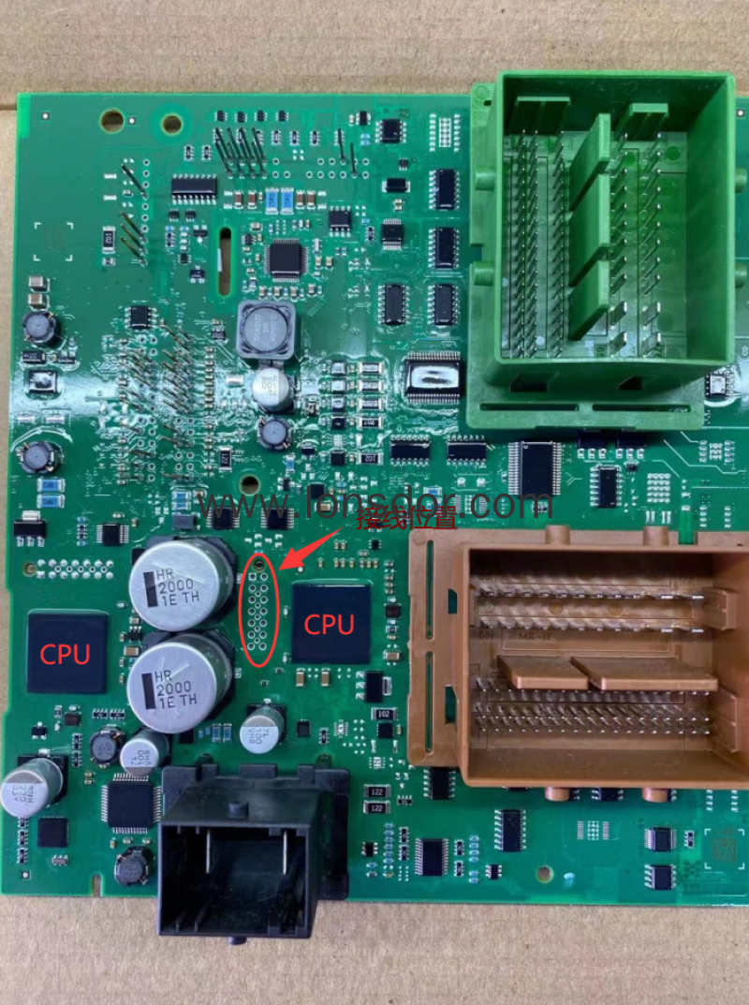

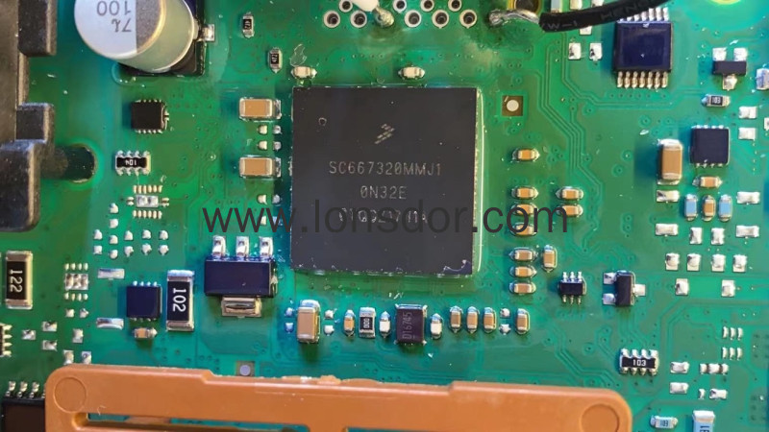

Wiring method:
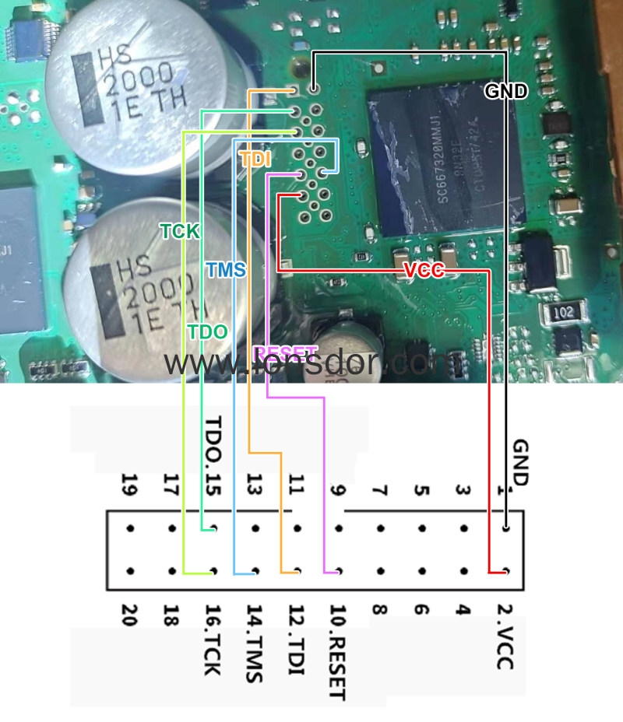

(2) Type 2: one CPU with chip no.MPC5748G on PCB
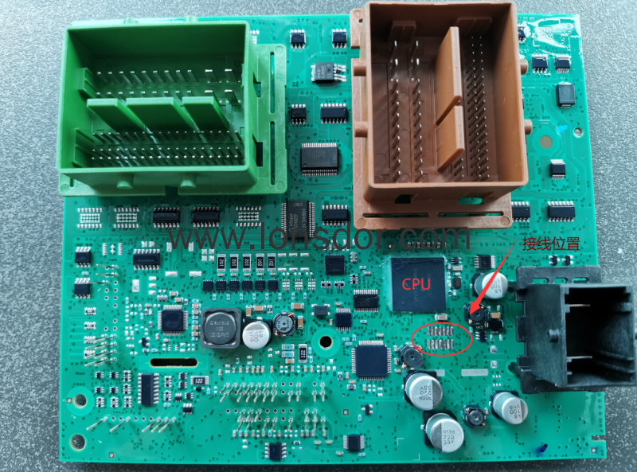
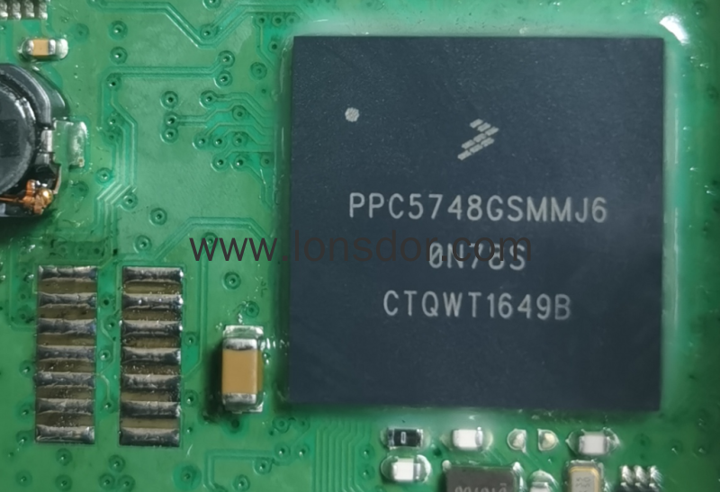

Wiring method:
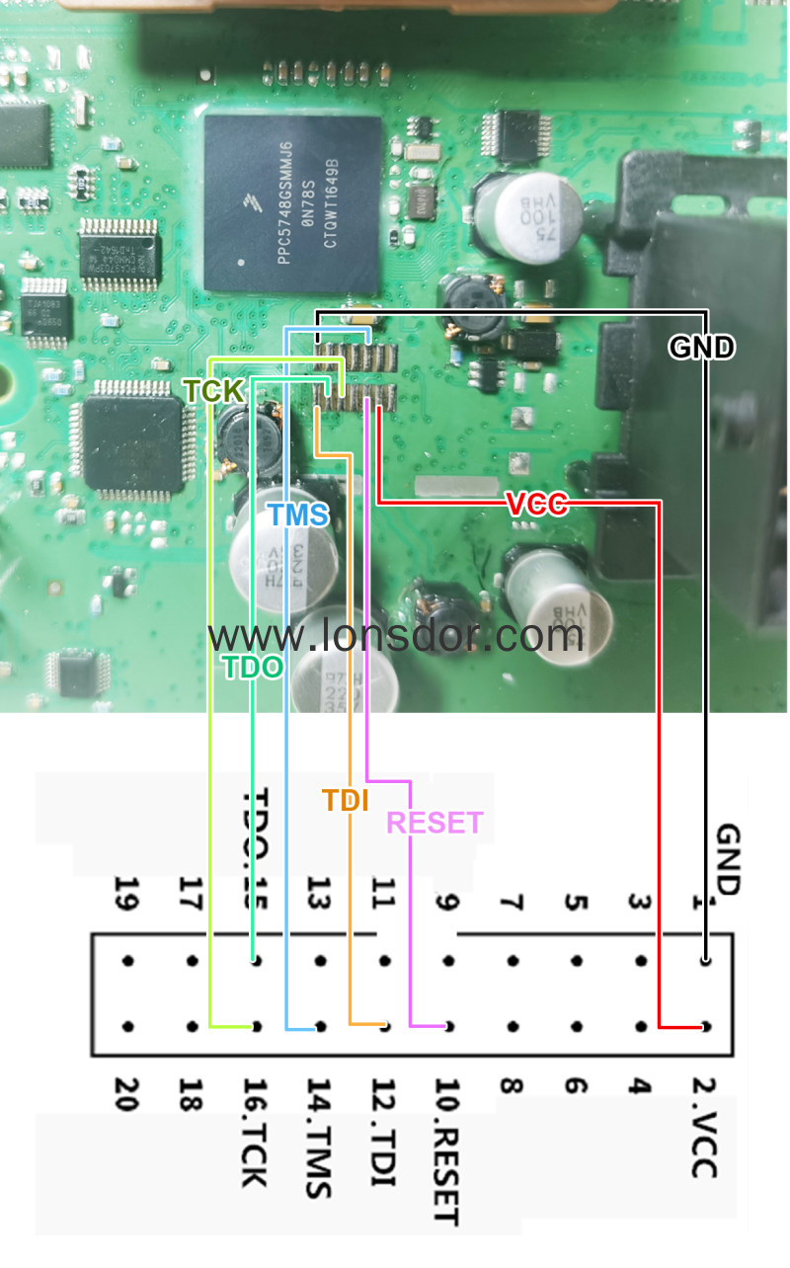

Use KPROG adaptor to read CEM data(actual photo):
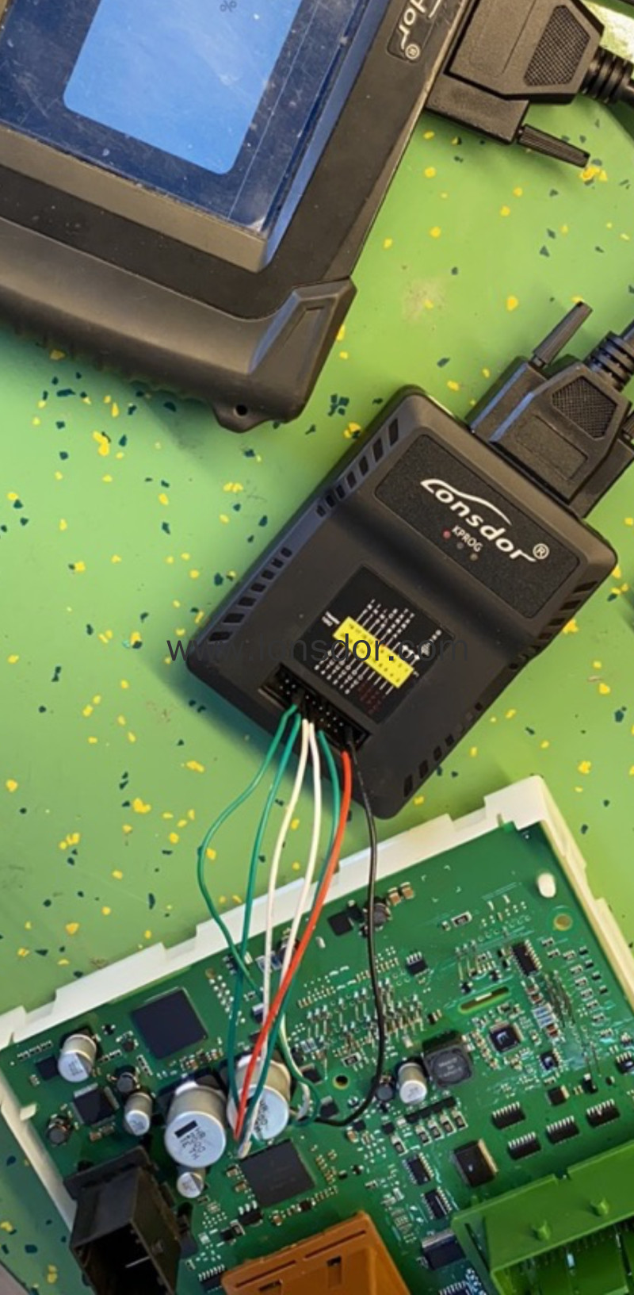

Attention
Key induction area:
Key induction area is in the cup holder or armrest box.
New keys with buttons at the side, can be repeatedly programmed on different cars, no need to delete keys.
When read CEM data, if it prompts 'Run APP failed', please exit the main menu, and update firmware and install adaptor; if it propts 'reading failed'(9FFF), please contact the aftersales to check OBD cable problem.
Requrie to bind the adaptor for the first use. Please connect k518 host with the adaptor properly, then enter the device menu: [settings]->[bind adaptor], follow the prompts to operate. One device can bind up to 5 new adaptors, and the bound adaptor cannot bind to other devices. No need to bind again after binding once.
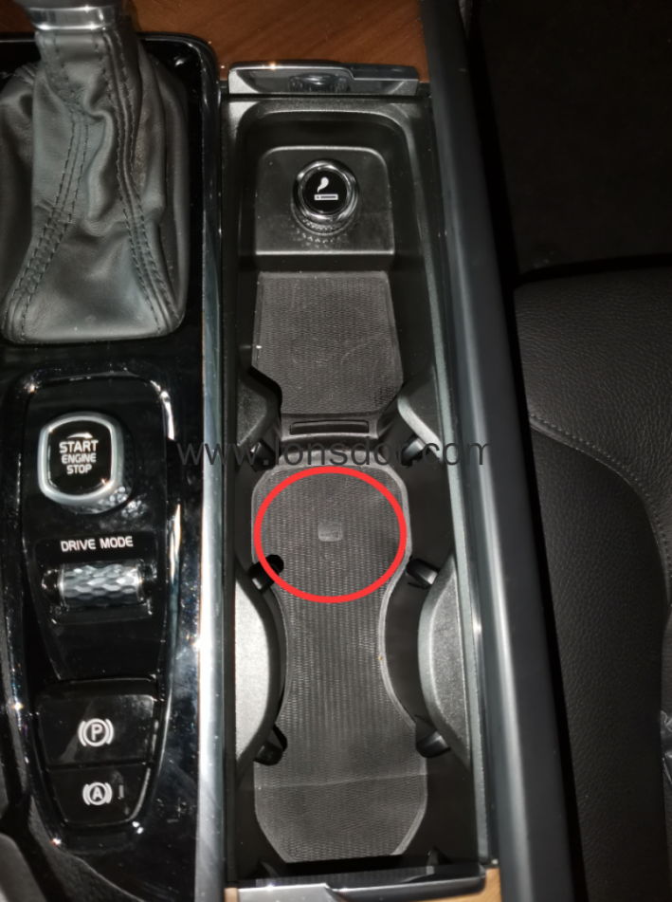
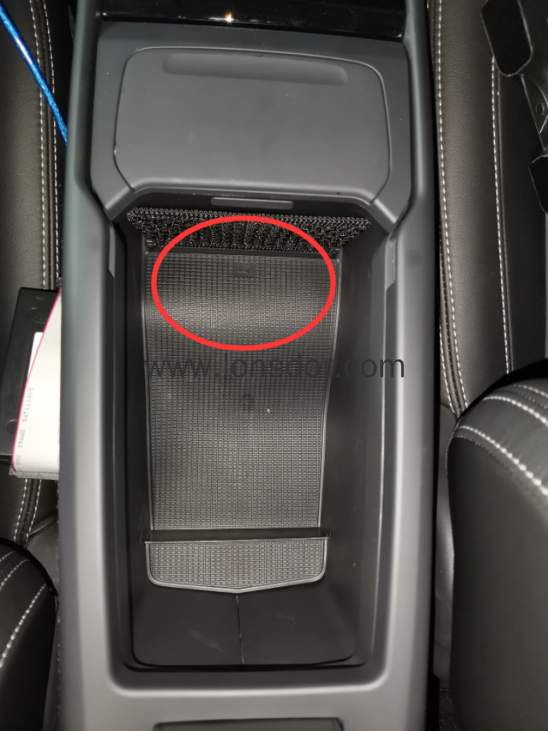

Reference
Chip type: 8A chip 128 bit

Program transponder/chip: Yes

mote type: Smart key with 3-button at the side

PIN code required: No

Dealer key required: No

Working key required: No

Remote generation: Remote control generates automatically when key programming is complete.

OBD position: Under steering wheel
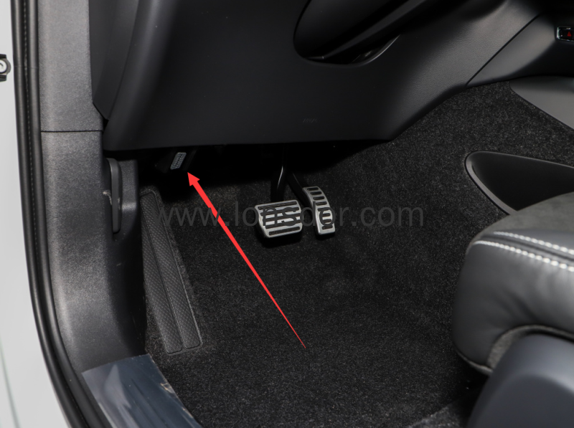

Vehicle type


Key pic
